**Q1:**

**Constraints:**

1. The company currently rent only passenger cars.

2. The company has several different makes of cars in its rental fleet, from different manufactures. Each make may have several models. The models are grouped into small number of price classes.

3. The online reservation will be voided if the customer doesn’t show up to pick up cars in a given period of time.

**Requirements:**

**R1.** The system should be able to make reservation and returned from same or different location, the system must provide a message to inform the custom the pick up time period otherwise the reservation will be voided.

**R2.** The system must have a car information record system to record the cars' information like make model year at.mt, car status....

**R3.** The system must be able to group the cars from brands, models, doors, prices, at/mt, hatch back/sedan...

**R4.** The system must provide an online reservation form for the customer and the system should process the form for single car rental or block rental, The system must able to provide several different rental plans for the customer when checking,

**R5.** The system must have a availability check system, before checking, If the selected car is not available, the system should display a message telling the customer that the car is rent out and let the customer select another one or suggest similar models of the different make.

**R6.** The system must have a credit card processing system.

**R7.** The system must able to process the invoice for one or more car rental reservations and the system must be able to decide the type of the invoice, e.g, to person or to company.

R8. The car must have a status tracking system,e.g, track the maintenance, repair... record.

**Q2:**

**Domain Model:**

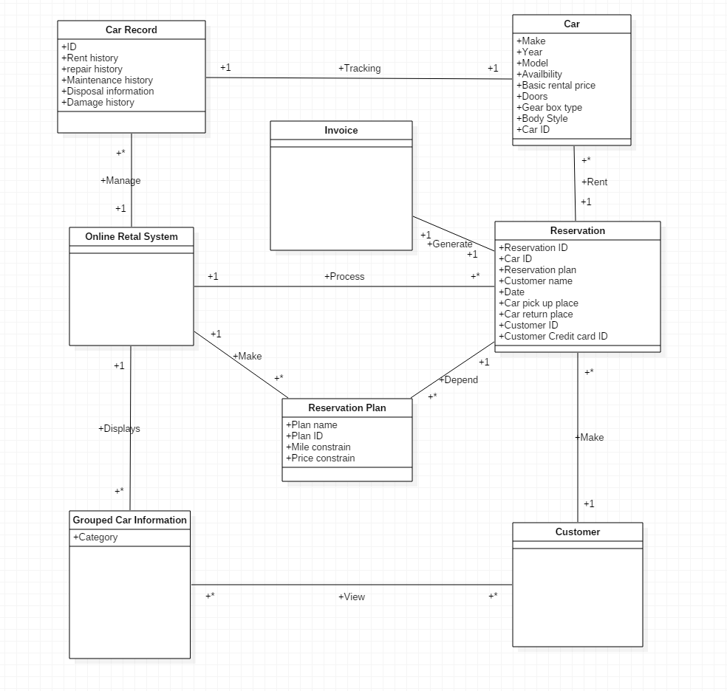

**Q3:**

This is a B/S web application.

**Architectural design:**

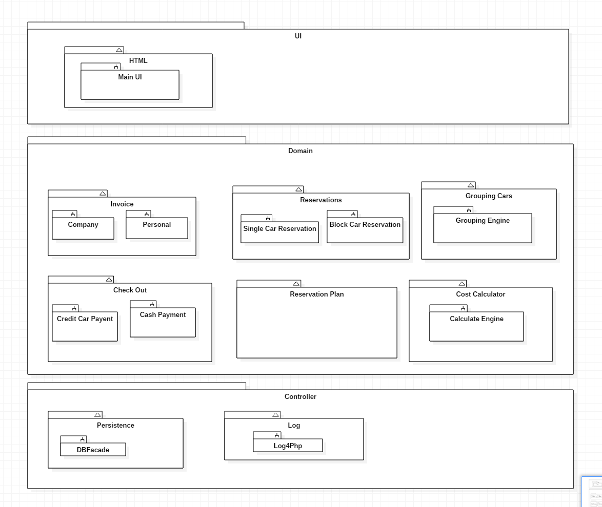

**Q4:**

**Use case UC1:** Make Reservation

**Use case UC2:** Record Cars

**Use case UC3:** Group Cars

**Use case UC4:** Check availability

**Use case UC5:** Similar Car Suggestion

**Use case UC6:** Check Out

**Use case UC7:** Print Invoice

**Use case UC8:** Tracking cars

|  |  |
| --- | --- |
| **Requirement and Use Case Mapping** | |
| Requirement | Use Case |
| R1 | Use Case UC1: Make Reservation |
| R2 | Use Case UC2: Record Cars |
| R3 | Use Case UC3: Group Cars |
| R4 | Use Case UC1: Make Reservation |
| R5 | Use Case UC4: Check availability Use Case UC5: Similar Car Suggestion |
| R6 | Case UC6: Check out |
| R7 | Use Case UC7: Print Invoice |
| R8 | Use Case UC8: Tracking Cars |

**Use Case Diagram:**

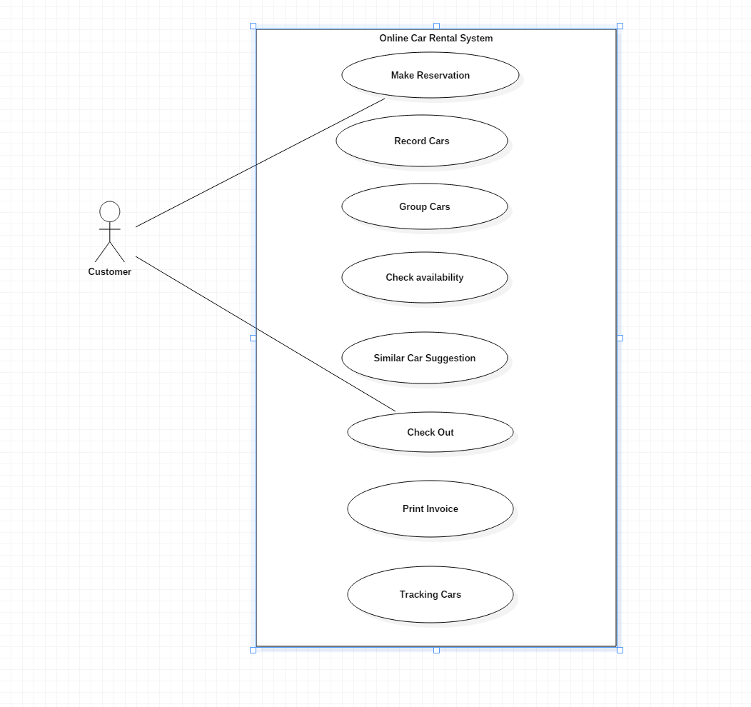

**Use case UC1:** Make Reservation

**Use case UC2:** Record Cars

**Use case UC3:** Group Cars

**Use case UC4:** Check availability

**Use case UC5:** Similar Car Suggestion

**Use case UC6:** Check Out

**Use case UC7:** Print Invoice

**Use case UC8:** Tracking cars

**Q5**

**(1)**

**Use Case UC1: Search Car**

**Primary Actor:** Customer (Primary)

**Stakeholders and Interests:**

-User: wants to be able to find ads for specific car

-**Precondition:** User has open the Online Car Reservation Website and the system works normally

**-Success Guarantee (Post conditions):** Search results are properly presented to user

**-Main Success Scenario (or Basic Flow) :**

1. User enter the search conditions, like rental location, drop of in the same place or not, drop off location, rental period, in provided area
2. System run search function on server based on the information provided by user and provide a search result for user
3. User obtain the car information and user user the filter function, like sort the search result by band, price, etc, provided by the website to look for a proper car
4. User repeats step 2-3 until user is done for searching for a car

**-Extensions: (or Alternative Flows):**

1. a. System find no results based on user’s search condition.
2. System notice user for no results and prompt search advice for user

**Use Case UC2: Reserve Car**

**Primary Actor: Customer**

**Stakeholder and interests:**

- Customer: wants to make a car rental reservation online

**Preconditions: Customer find a satisfied car by the searching function**

**Success Guarantee (Post conditions):**

- Customer successfully make a reservation

**Main Success Scenario (or Basic Flow):**

1. Customer select one or more cars and click the reserve bottom on website page
2. System receive the information, figure out the total cost for each possible rental plan and provide to customer
3. Customer choose one of the rental plan and click confirm bottom
4. System confirm the reservation and prompt a e-receipt for the customer

**Extension:**

1. a. System find out the car is not available
2. System notice customer for the car is not available and encourage customer choose another car
3. Customer choose another car and re-click conform bottom

3.a. Customer click cancel bottom

1. System brought customer back to car select page

**Use Case UC3: Edit Reservation**

**Primary Actor:** Customer

**Stakeholder and Interests:**

- Customer: Wants to edit his reservation

**Precondition:** The customer has already made a reservation in the system

**Success Guarantee (Post conditions):**

- Customer’s reservation has successfully edit

**Main Success Scenario (or Basic Flow):**

1. Customer click “my reservation” bottom on the web page
2. System prompt the information chart for user
3. Customer enter the reservation information to find his/her reservation
4. System show user the reservation
5. Customer select on reservation and click edit bottom
6. System provide a temporary reservation form based on customer’s reservation
7. Customer edit the reservation information and click confirm bottom
8. System receive the data and save the changes and prompt success information to customer

**Extensions:**

1. a. Customer’s edit is illegal
2. System prompt error massage to indicate which part is wrong
3. Customer re-edit the illegal part and click confirm bottom

**Use Case UC4: Cancel Reservation**

**Primary Actor: Customer**

**Stakeholder and Interests:**

**- Customer: Wants to cancel a reservation online.**

**Precondition:** The customer has already made a reservation in the system

**Success Guarantee (Post Conditions):**

- The reservation has successfully canceled

**Main Success Scenario (or Basic Flow):**

1. Customer click “my reservation” bottom on the web page
2. Customer selects one reservation and click cancel reservation button.

3. System prompt dialog to confirm the cancellation.

4. Customer click Yes button.

5. System set the statue of the reservation as cancel

**Extensions (or Alternative Flows):**

3.a. Customer click No button:

1. System back to reservation selection page

**Q5(2)**

**Sequence diagram**

**Search Car**

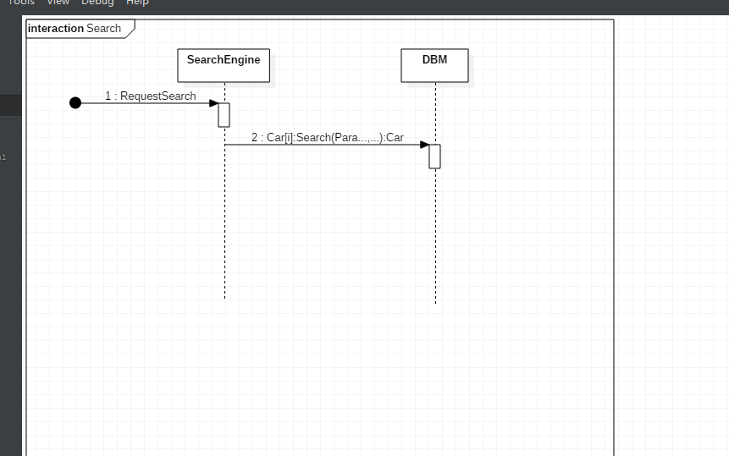

Description: wed front end pass search criteria into search engine, search engine interpret it into a series of SQL, and retrieve data from DBMS to form a result

**Reserve Car:**

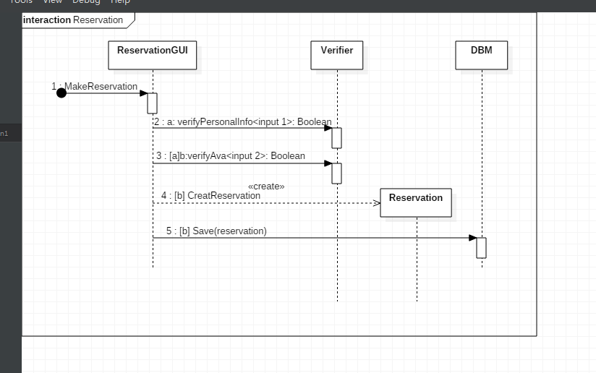

Description: Web front end pass reservation data from user into verifier and confirm the reservation is valid, if valid, then pass the reserve data into DBMS

**Edit Reservation:**

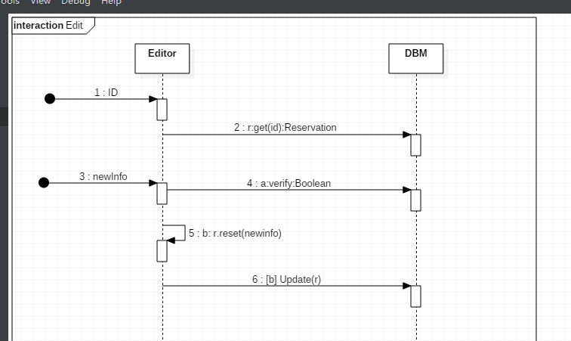

Description：Web front end pass reserve ID into editor and editor retrieve data from DBMS based on the reserve id. Editor generate an temperate form based on the data from the DBMS, user edit the provided form and editor verify the if the form is valid by connecting to the DBMS, if it’s valid, then update the data from DBMS.

**Cancel Reservation:**

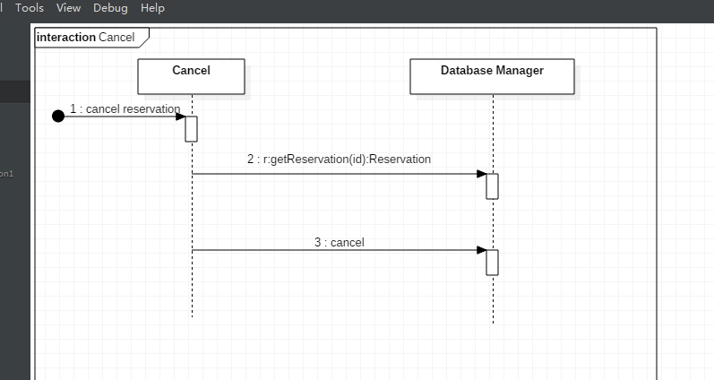

Description: when cancel, the system not delete the reservation from the DBMS, instead, it update and set the statues of the reservation into cancel.

**Q6 Design Class Diagram：**

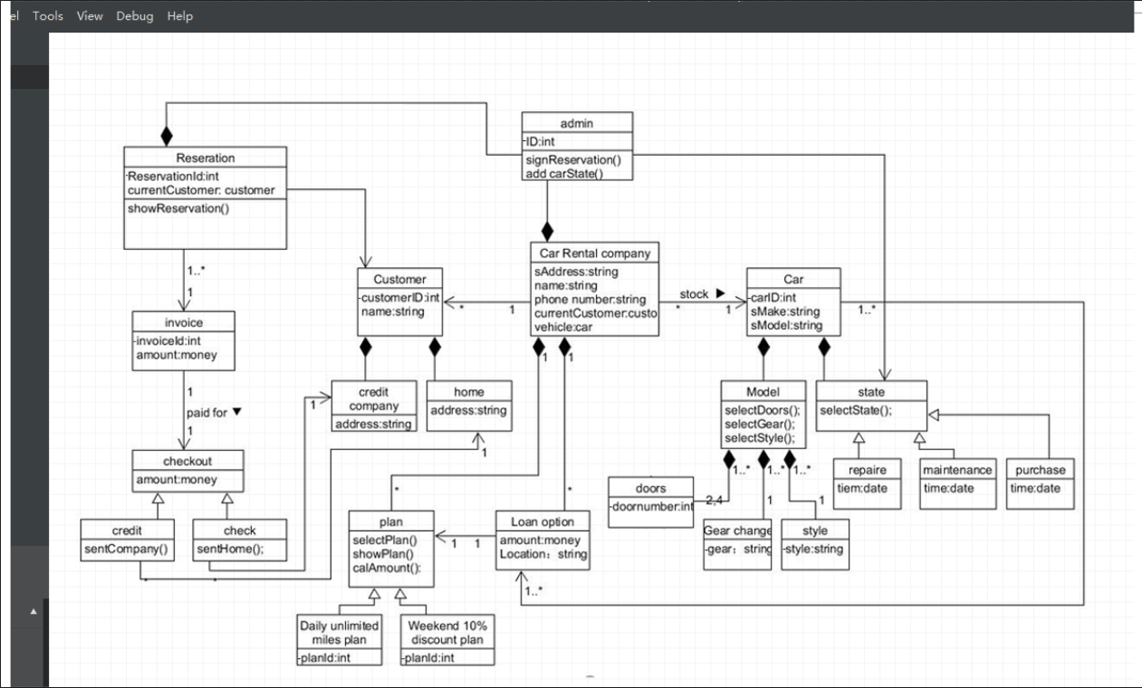

Description: The diagram is based on the design sequence diagrams, Q1-Q5, and the project description. Some of the attributes has set to private based on the actual needs.